

**FAKE CURRENCY DETECTION SYSTEM**

By

JITENDRA AGRAWAL 19BEC1252

SOURABH BELGAL 19BEC1125

MAHARSHI ROY 19BEC1746

A project report

Submitted to

**Dr. GEETHA BALAN**

**(SCHOOL OF COMPUTER SCIENCE & ENGINEERING)**

in partial fulfilment of the requirements for the course of

**CSE3018 – CONTENT BASED IMAGE & VIDEO RETRIEVAL**

in

**B. Tech. COMPUTER SCIENCE AND ENGINEERING**

**Vandalur – Kelambakkam Road**

**Chennai – 600127**

**ACKNOWLEDGEMENT**

*Presentation inspiration and motivation have always played a key role in the success of any venture.*

We express our sincere thanks to Dr. Geetha Balan, Vellore Institute of Technology Chennai Campus to encourage us to the highest peak and to provide us the opportunity to prepare the project and whose valuable guidance and kind supervision given to us throughout the course which shaped the present work as its show.

We are immensely obliged to our friends for their elevating inspiration, encouraging guidance and kind supervision in the completion of our project.

Last, but not the least, our parents are also an important inspiration for us. So with due regards, we express our gratitude towards them for their constant belief in us.

**JITENDRA AGRAWAL**

**SOURABH BELGAL**

**MAHARSHI ROY**

**ABSTRACT**

The number of counterfeit notes in circulation has increased dramatically in recent years. Counterfeiters are constantly devising new methods to get as close to the real thing as possible. Fake currency is a problem in a lot of countries. One of them is Indian. Anyone may now print false currency thanks to advancements in technology. These notes are printed without the state's permission, and the continued manufacture of such notes can harm a country's economy. Ordinary folks will be unable to tell whether the money is real or phoney when such counterfeited notes are made and circulated since they differentiate based on physical appearance. The general population is in dire danger of losing their hard-earned money as a result of this. Several researchers have sought to create various methods for identifying counterfeit notes in order to address this issue. Traditional colour, width, and serial number-based strategies and methods for identifying counterfeit cash are available. Based on computer science and modern computational methodologies, image processing presents a number of machine learning techniques that provide good accuracy for the fake identification of currency. Algorithms are used to detect and recognise elements on the note such as colour, form, paper width, and image filtering.

**TABLE OF CONTENTS**

|  |  |  |
| --- | --- | --- |
| **SERIAL NO.** | **TITLE** | **PAGE NO.** |
|  | **ACKNOWLEDGEMENT** | 2 |
|  |  |  |
|  | **ABSTRACT** | 3 |
|  |  |  |
| 1 | **INTRODUCTION** | 5 |
|  |  |  |
| 2 | **LITERATURE SURVEY** | 6 |
|  |  |  |
| 3 | **PROPOSED WORK** | 7 |
|  |  |  |
| 4 | **EXPERIMENTAL SETUP & RESULT** | 9 |
|  |  |  |
| 8 | **CONCLUSION** | 11 |
|  |  |  |
| 9 | **REFERENCE** | 11 |

**INTRODUCTION**

The notion of counterfeit currency has existed since the inception of cash. Long before notes were employed as money, counterfeiters tampered with various types of payment to earn more value than the exchanged item was worth. Since then, counterfeit money has grown into a massive criminal industry. Some of the negative effects of counterfeit money on society include a decrease in the value of real money, inflation as a result of more money being circulated in society or economy, which dampens our economy and growth - an unauthorized artificial increase in the money supply, a decrease in the acceptability of paper money, and losses. In order to avoid counterfeiting, many money identification machines are currently available on the market. The issues associated with fake currency identification may be successfully solved by a high-speed and trustworthy image processing technique. Even though digital image processing is a highly effective approach for detecting counterfeit money, the optimal combination of algorithms must be used to achieve the best results. Previously, a number of researchers sought to integrate several feature extraction techniques in order to develop an optimum algorithm for the implementation of fake banknote identification, but their efforts typically resulted in a reduced accuracy rate. A realistic comparison is attempted in this work. Following the successful implementation of the suggested method, a comparison of individual OpenCV algorithms is performed. Many money recognition machines are currently available on the market to help prevent counterfeiting. A high-speed and reliable image processing technology may be able to successfully overcome the challenges connected with fake currency identification.

**LITERATURE SURVEY**

In [1] paper suggested algorithms like Mean Square error, SVM, C4.5 Decision Tree, ANN and HSV. Merits: The most efficient algorithm is Mean square error. It provides 100 percent accuracy with permissible 1 percent error. Demerits: 1. SVM: In cases where the number of features for each data point exceeds the number of training data samples, the SVM will underperform. 2. C4.5 Decision Tree:93.94 percent accuracy with 90 percent training set data and 10percent testing set data. 3. HSV: Its accuracy is algorithm dependent.

In [2] paper suggested algorithms like using K-nearest neighbours, Support vector classifier and Gradient Boosting Classifier. Merits: TMerits: The K-nearest neighbours is the most efficient algorithm which provides 99.9 percent accuracy. Demerits: 1. Support Vector Classifier: if the number of features are greater than the number of sample the algorithm is likely to underperform and it is quite taxing to train. 2. Gradient Boosting Classifier: they consume a lot of memory and can be very time consuming with the ensemble is large. 3. KNN: a lot of heavy computation work happens while testing which makes it a slow algorithm

In [3] paper suggested algorithms like using K-nearest neighbours, Support vector classifier and Gradient Boosting Classifier. Merits: Information of OCR can be readable with high degree of accuracy. Demerits: 1.OCR doesn’t work on every character and fails in less quality of images. 2. The facial recognition system can faked easily. 3. Hough transformation algorithm may detect lines other than security ultraviolet lines.

In [4] paper Uses canny edge detection and for feature extraction the intensity of each feature is measured by counting the number of white pixels. Merits: As Indian notes have very complex details the canny edge detection is one of the best methods also various security features that are considered in the Indian currency are extracted. Demerits: 1.Since edge detection can become mess easily so no filter is applied to smooth the edges. 2. The feature extraction in this paper is not accurate as it is compares the calculated white pixels

In [5] Sharan and Kaur suggested a method for distinguishing between genuine and counterfeit notes that involves measuring the mean intensity of RGB channels in a picture and collecting three separate features such as the Latent image, RBI logo, and denomination numeral with Rupee symbol. The accuracy of the proposed system is very good.

**PROPOSED WORK**

**Creating Dataset**: A sample database of 100 samples is taken into account. There are 50 fake notes and 50 genuine notes in the reference database. The notes in the dataset are in denominations of 500, 100, 200 and 2000 Rs.

**Image Acquisition**: Scanners, sensors, cameras, and other devices can all be used to obtain an image. Here, we’re leveraging the camera on the user’s smartphone. The cash note in question is supposed to be held up to the camera. The image of the money in the light has been caught. The picture data from this camera will be sent to the python REST API, where it will be analysed for further analysis. This is the most fundamental and crucial stage in image processing. Using a machine like the VSC 5000 would be a different method (Visual Spectral Comparator). It captures multiple sections of a banknote using a spectrometer and other built-in light sources. The centre design of the note is well-suited to the UV light of the machine. As a result, UV rays may be used to scan this area. Various different light sources can extract certain needed parameters or latent signs in the same way. VSC 5000 can overcome the pre-processing done to boost critical characteristics and minimise unneeded distortions.

**Extraction of Features**: The most crucial and difficult step is extracting characteristics. The effectiveness of our algorithms will be determined by how quickly we process the security aspects of the notes. It’s really tough to duplicate these characteristics. It’s possible that a false note will get a few of them practically perfect, but it’s impossible to get them all correctly, which is why it’s best to consider a larger number of attributes.

**Comparison**: This is the last step of this process here the features extracted from original currency are compared with features extracted from testing currency. After the features are extracted from original currency the white pixels are calculated and recorded. Then the features of testing currency are extracted and their respective white pixels are calculated. We are going to use Mean square error algorithm for the same.

**Result**: The features are compared based on the intensities of the features (pixel count). Based on the number of matched features, the results are obtained on whether the currency is original or fake.

**EXPERIMENTAL SETUP & RESULTS**

Dataset Used

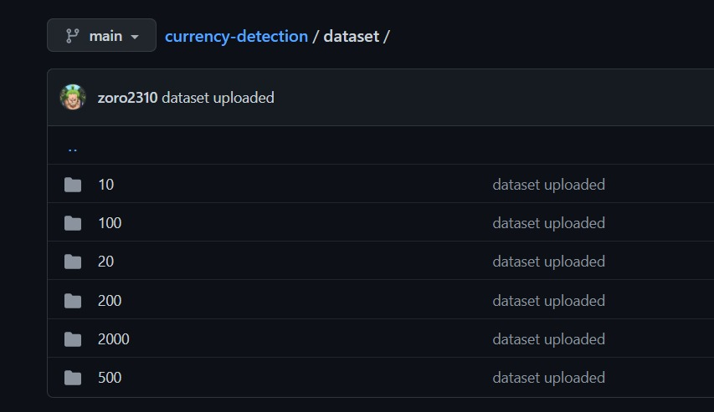

Sample Currency Notes

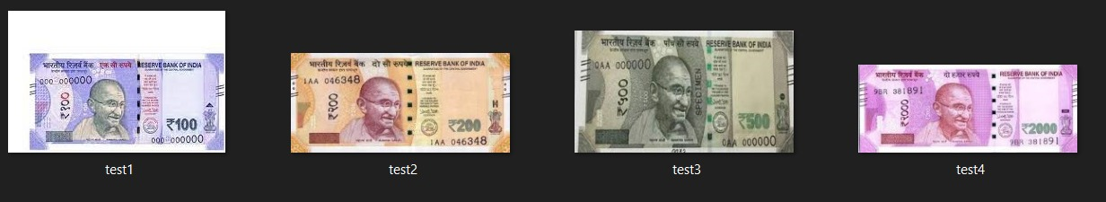

Fig: Output for For Test Image 2 of Rs. 200

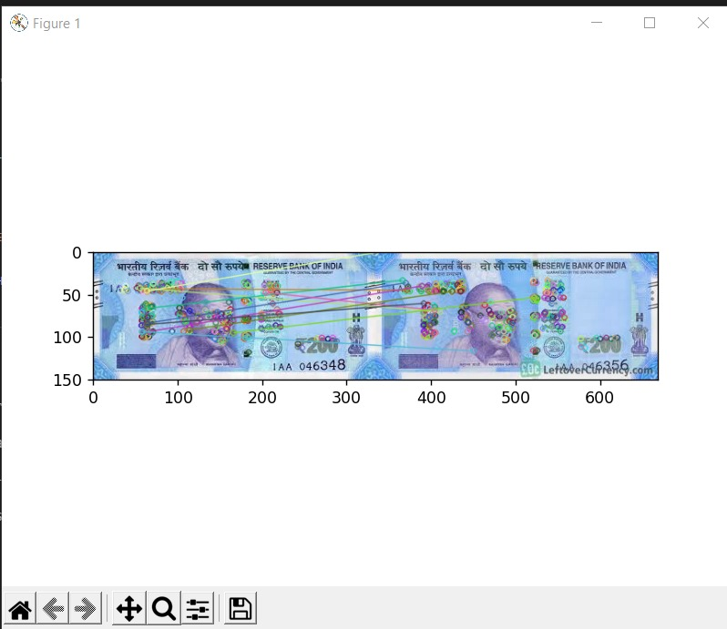

Fig: Output for For Test Image 1 of Rs. 100

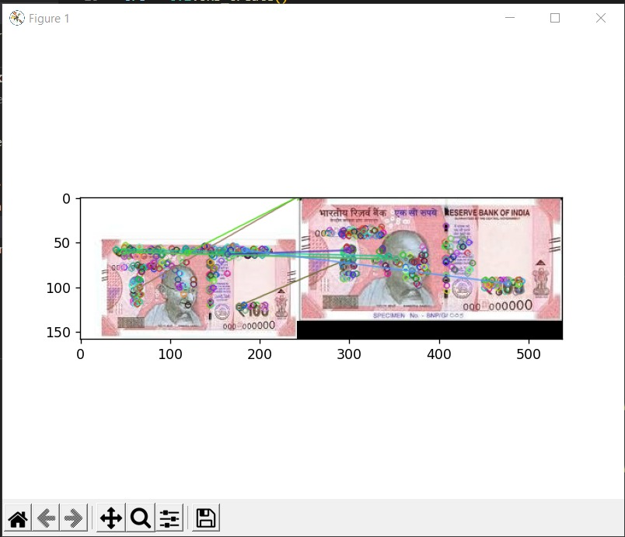

**CONCLUSION**

There are several methods for determining whether or not a piece of currency is counterfeit, but all of them follow the same stages. Image acquisition, edge detection, segmentation, grayscale conversion, and binarization are the steps involved. Most of these studies use MATLAB to perform their calculations, but we ended up utilising OpenCV and Python as our programming language. In order to make comparisons and determine the outcome, a set of characteristics that identify original currency from counterfeit currency are assessed. Identification markers, see-through registers, optical changeable ink, currency colour codes, security threads, watermarks, latent images, and micro-lettering are just a few of the features available.

**REFERENCES**

[1] Detection of Counterfeit Currency using Image Processing Techniques by Priyanka Dhapare, Akash Agrawal and Devangi Doshi. 2019

[2] Fake Currency Detection with Machine Learning Algorithm and Image Processing Aman Bhatia , Vansh Kedia and Anshul Shroff 2021

[3] A Hybrid Fake Banknote Detection model using OCR, Face Recognition and Hough Features by Dr. Adiba Zarin and Jia Uddin 2019.

[4] Efficient Image Processing Technique for Authentication of Indian Paper Currency by Rencita Maria Colaco, Rieona Fernandes, Reenaz and Sowmya S. 2021

[5] V. Sharan and A. Kaur, " Detection of Counterfeit Indian Currency Note using Image Processing" , International Journal of Engineering and Advanced Technology, 2019.